ASP.NET Core Web API – Hands-on 5
Aim: To implement JWT (JSON Web Token) Authentication in an ASP.NET Core Web API application, secure API endpoints using the [Authorize] attribute, validate JWT tokens, implement role-based authorization, and verify token expiration using Swagger.
Theory:
- JWT (JSON Web Token): JWT is a secure, compact token used for user authentication and authorization between a client and server.
- Authentication & Authorization: Authentication verifies a user's identity, while authorization determines the resources or actions the authenticated user is allowed to access.
- Bearer Token: A Bearer token is sent in the HTTP Authorization header to access protected APIs.
- Authorize Attribute: The [Authorize] attribute restricts access to authenticated users only.
Procedure:
- Created a new ASP.NET Core Web API project named FirstWebApi.
- Installed the Microsoft.AspNetCore.Authentication.JwtBearer NuGet package.
- Configured JWT authentication in Program.cs by specifying the security key, issuer, audience, token validation parameters, authentication middleware, and Swagger security configuration.
- Created the model classes Employee, Department, and Skill.
- Created AuthController with the [AllowAnonymous] attribute.
- Implemented the GenerateJSONWebToken() method to generate JWT tokens containing UserId and Admin role claims.
- Generated JWT tokens using the GET /api/Auth endpoint.
- Secured the EmployeeController using the [Authorize] attribute.
- Verified that accessing the Employee API without a JWT token returned 401 Unauthorized.
- Authorized Swagger using the generated JWT token and verified that the Employee API returned 200 OK.
- Modified the JWT expiration time to 2 minutes and verified that an expired token returned 401 Unauthorized.
- Applied role-based authorization using [Authorize(Roles = "POC")] and verified that access was denied for a token containing the Admin role.
- Updated the authorization attribute to [Authorize(Roles = "Admin,POC")] and verified that the authenticated user with the Admin role could successfully access the Employee API.

EmployeeController.cs:
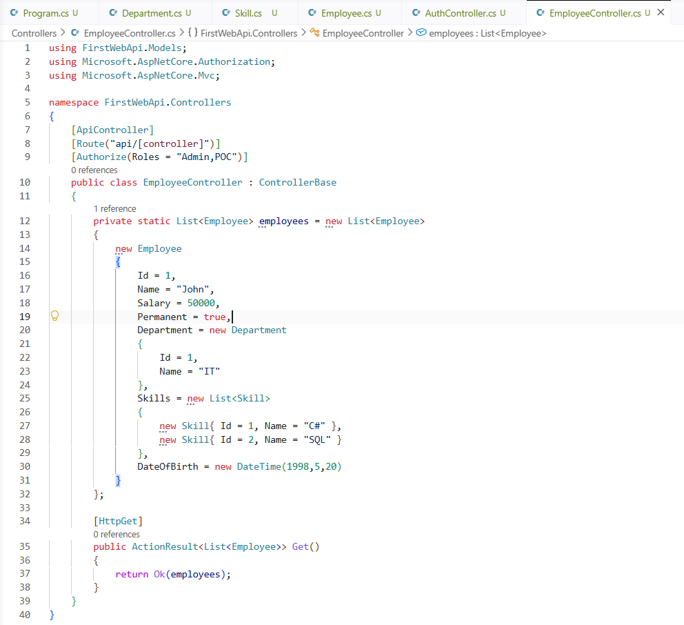

Outputs:
JWT Token Generated Successfully
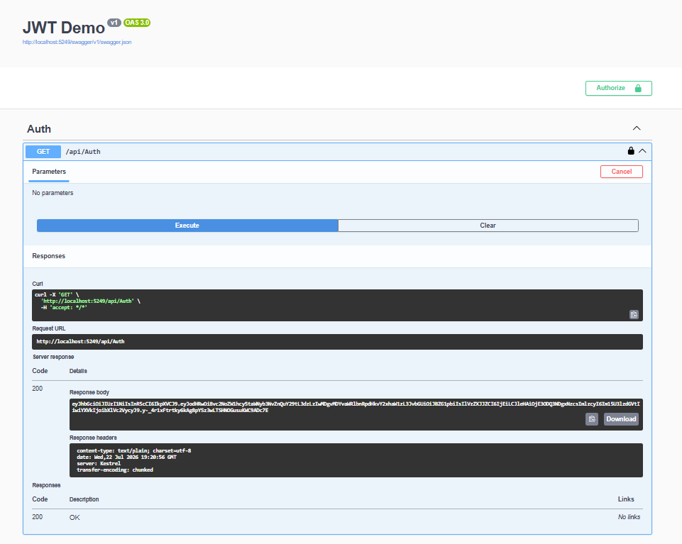

Employee API Access Without Token – 401 Unauthorized.
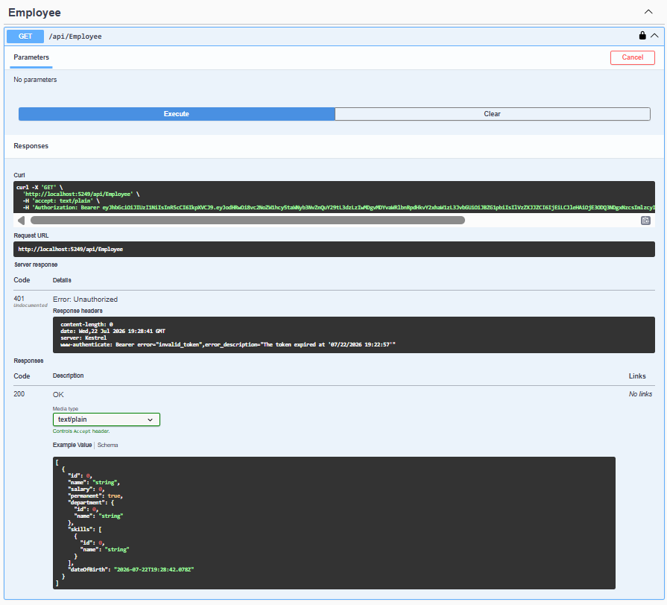
Employee API Access With Valid JWT Token – 200 OK.
